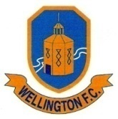

GDPR Statement
To conform with the GDPR [General Data Protection Regulations], Wellington FC has issued the following statement:-
- Data held by the club is a list of all members, their names, addresses, personal details, telephone numbers and email addresses.
- The data is held electronically and password protected, plus anti-virus software is used to safeguard the integrity of the information. A paper copy is held in a locked file.
- No data is given to a third party unless obliged to do so; ie to football leagues the club is associated with to enable players to be members of the league. To the FA for the Whole Game System and the Herefordshire FA for administration purposes.
- A copy of data held can be requested by any individual by writing to the club secretary and if found to hold errors can be rectified.
- Any data held for any member who has left the club will be destroyed.
- Any queries please contact the club secretary.

